ASTEROID WAR

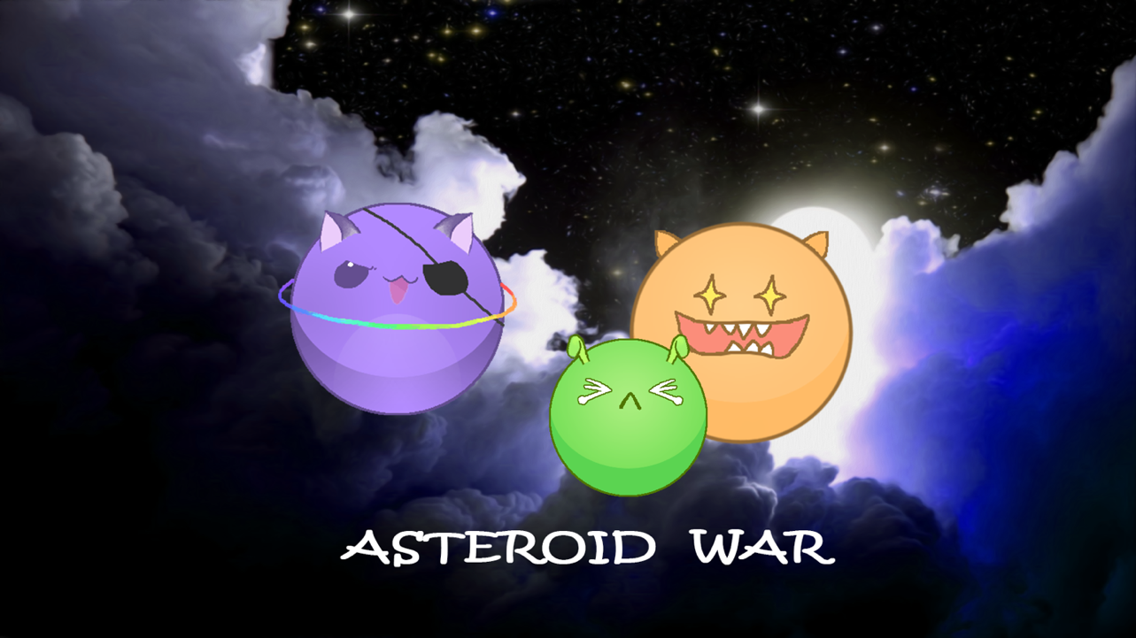

**Fight for our planet!**

Group T:

JIANG, Xinhong

PAN, Hao

ZHOU, Tingting

CHEN, Yingshu

3/12/2016

# Group Information

## Member Information

|  |  |  |  |  |
| --- | --- | --- | --- | --- |
| Name | JIANG, Xinhong | PAN, Hao | ZHOU, Tingting | CHEN, Yingshu |
| UID | 3035347990 | 3035349015 | 3035348621 | 3035349106 |

## Division of Labor

* Game Programming: JIANG Xinhong, PAN hao
* Game Algorithms: PAN Hao, JIANG Xinhong
* Game Design: All
* Document: All
* Background Research: ZHOU Tingting
* UI Design: CHEN Yingshu, JIANG Xinhong
* Sounds and music: JIANG Xinhong
* Final Code Integration & Video Recording: JIANG Xinhong
* Final Document Integration: CHEN Yingshu, ZHOU Tingting

# Background Research

Here list three similar games in the market – Battle of Balls, Nebulous, Agar.io.

## Battle of Balls

Battle of Balls is a cutesy but challenging real-time casual game in which you will control a ball to eat other players' balls smaller than yours around you to become the biggest one.

Features:

1. A variety of interactive elements: Players will be able to add friends, follow players, and own their followers, which makes you the stars in the world of Battle of Balls.
2. Spectator Mode: When the big bosses emerge, you can use Spectator mode to watch their fights and root for them
3. Team play: It supports team play together with voice chatting, group chatting.

Shortcoming:

1. A little user-unfriendly, for example, when playing the game, there is no button for pausing or quitting the game; the setting of board of moving area damages the sense of game scene, which really influences user experience.
2. Does not set game difficulty level, you can last the game for very long time unless eaten by others, during which player would easily feel board.

Possible improvements:

Add some necessary buttons or labels to increase user-friendliness. Set different difficulty levels, for example, in one of levels, the player must obtain some aim weight in limited time, which is considered “pass this level”.

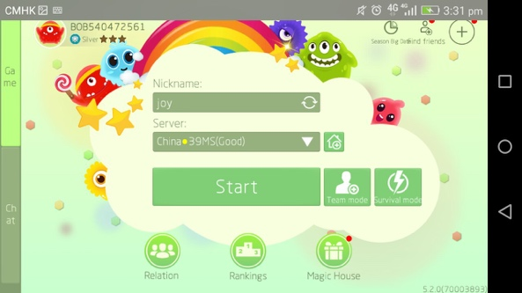 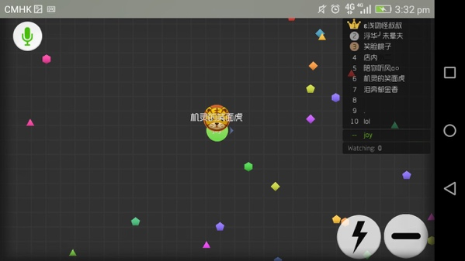

**Initial interface**  **Game playing interface**

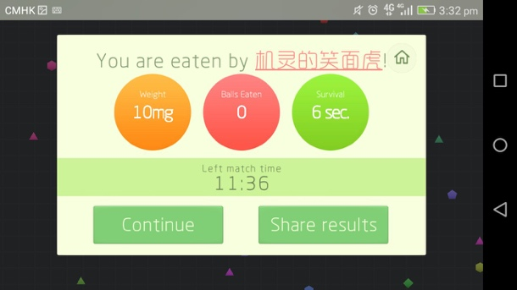 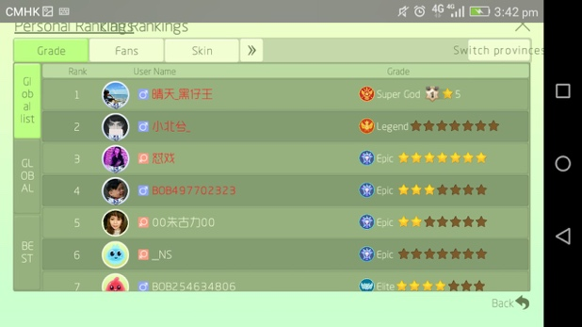

**Game result interface**   **Ranking interface**

(Ref: http://2p.com/34710267_1/Battle-of-Balls-Play-Balls-with-Players-Worldwide-by-minishop.htm)

## Nebulous

Grow the blobs by collecting dots placed throughout the game or gobbling up smaller players. Avoid bigger players attempting to do the same. Compete with other players to become the biggest blob.

Features:

1. Players can find groups, join a clan and play with friends.
2. Over 450 skins with unique ways to unlock them and players can upload their own custom skin for other players to see.
3. Online Multiplayer (up to 27 players per game) or Offline Single-player.
4. Various game mode: FFA, Timed FFA, FFA Classic, Teams, Timed Teams, Capture the Flag, Survival, Soccer and Domination Modes!

Shortcomings:

An evident shortcoming similar to Battle of Balls: the setting of board of moving area damages the sense of game scene, which really influences user experience.

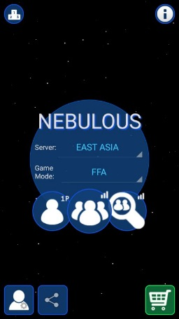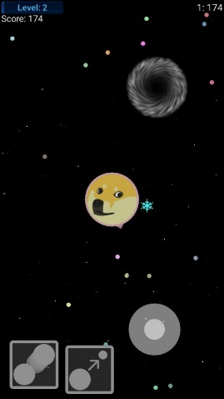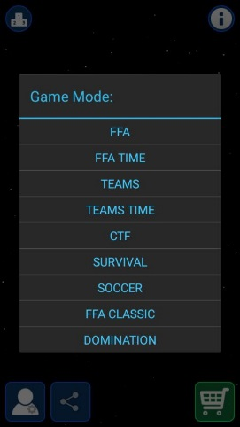

**Initial interface Game playing interface Game modes**

Ref: https://play.google.com/store/apps/details?id=software.simplicial.nebulous&hl=en

## Agar.io

Features:

1. Online multiplayers
2. A variety of special secret skins with the right username
3. Actions of splitting, shrinking and dodging tactics to catch other players

Shortcoming: The game is a bit lagged and of too many adds.

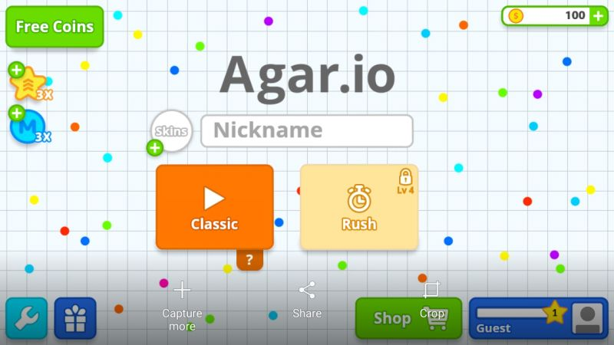 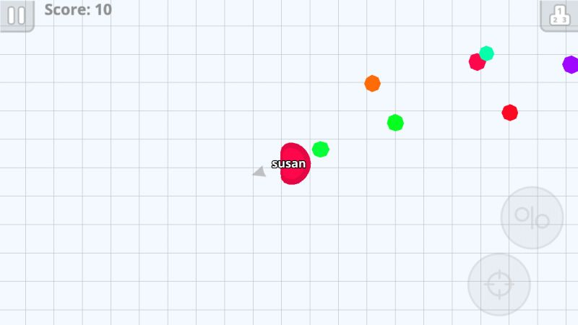

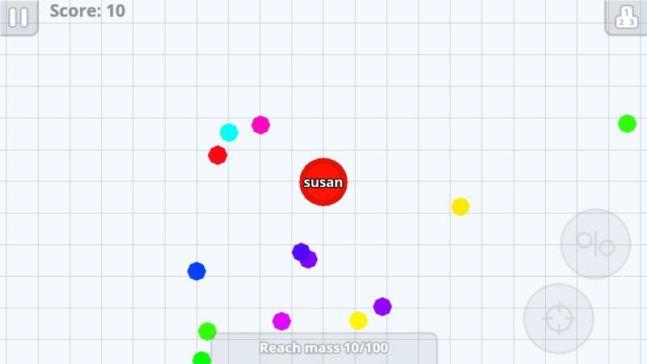 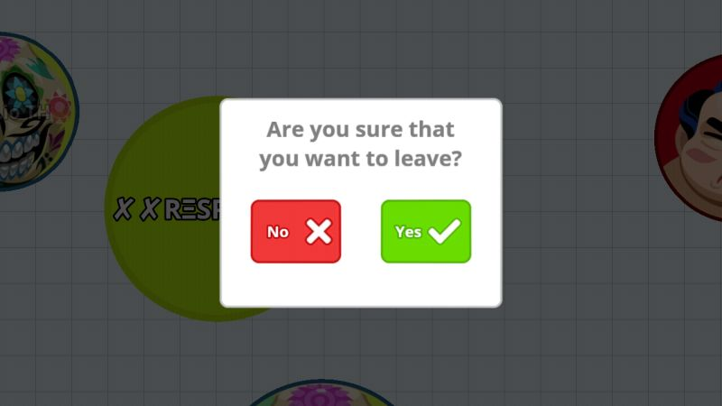

Game Interface

Ref: <https://play.google.com/store/apps/details?id=com.miniclip.agar.io>

Based on above games, we develop a new game for offline single-player competing with enemies played with artificial intelligence in iOS platform by means of game engine Cocos2d-x. Also, we add more interesting playing modes and skills to our game.

# Game Overview

It is an entertainment and strategy game application on philosophy of survival of the fittest.

To be the strongest species to survive, the asteroid in universe have got to be as much bigger and stronger as possible by eating other smaller ones around it in defense of attacks from enemies.

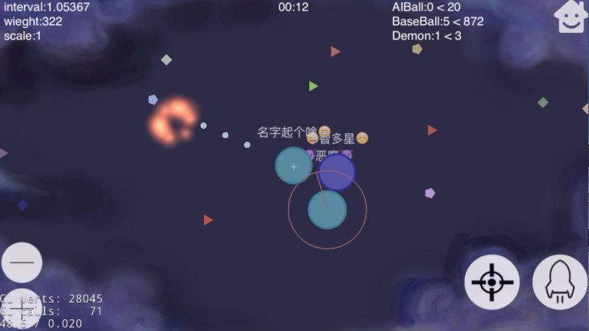

Figure-Game scene

To be the very surveillance of the universe, keep poking to move, eating others to collect energy and gain weight. It is weight and size that can prove the ability and power. When weight is large enough to dominate the universe, you become the king of asteroids in the universe.

It is your show time to protect your village using your intelligence and skills. The history records will tell you how honorable your achievement is.

# Detailed Game Description

## Background Story

In Universe, battles often occur. The player is one of the asteroids struggling to survive from battles and become the dominator of the universe. The player keeps moving to trace enemies and collect energy, and eludes quickly the bigger enemies to sustain your power, until this battle ends up.

## Objective

The objective is to survive from being encroached and eliminate enemies. To be powerful enough, the hero is supposed to eat smaller ones as many as possible to gain weight and get a larger size. The hero also can use bullets to defeat demons to get higher score. The player can break the history record by eating lots of asteroids and defeating as many demons as possible. To add the challenge of the game, we set two game modes – unlimited-time and timer.

In the unlimited-time mode, the player has to control the hero to eat other asteroids and defeat demons as many as possible. Meanwhile, the hero should avoid being encroached or attacked by the bigger ones, otherwise the game will be over. The final score will be calculated when the game is over and the highest score will be recorded.

In the timer mode, the hero tries to eat smaller ones and defeat demons as many as possible within a period of certain time. The final score will be calculated when the limited time is up or the hero dies in halfway and the highest score will be recorded.

## Gameplay

### Storyboard

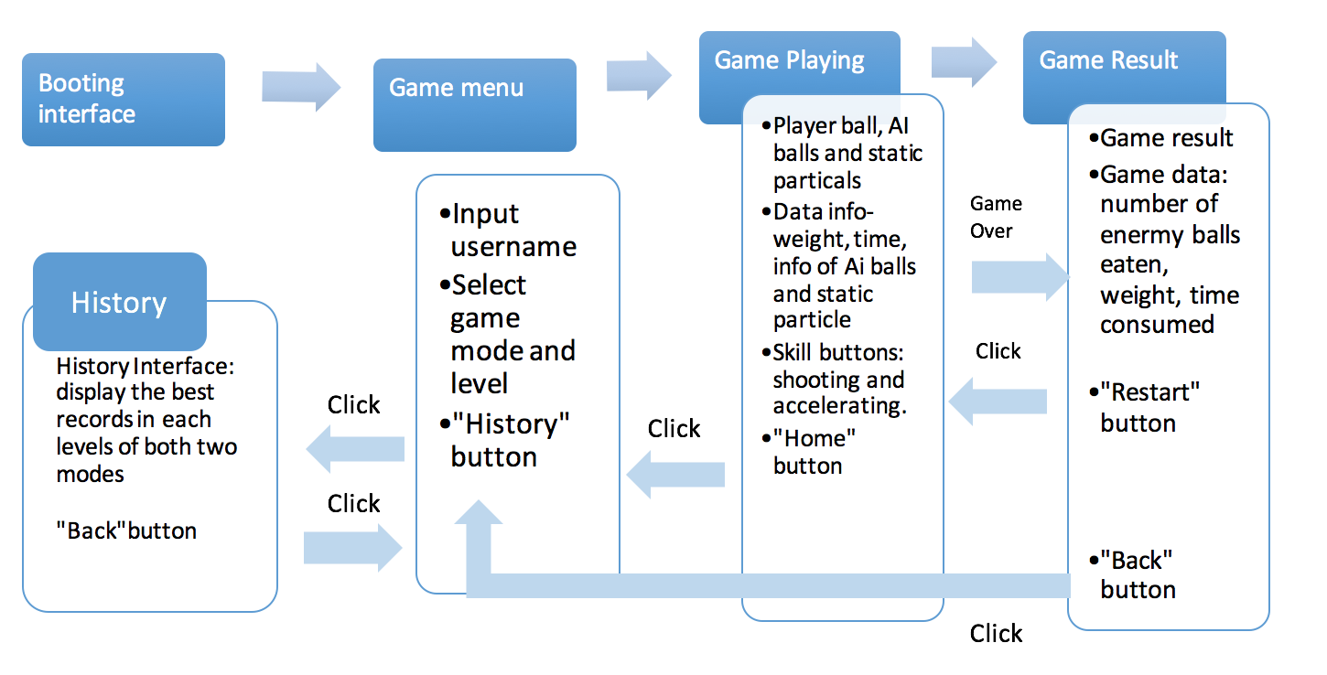

Figure-Game Flow

1. Booting

There is an unavoidable welcome interface showing a short period of time on the screen, displaying the game title, main characters and content.

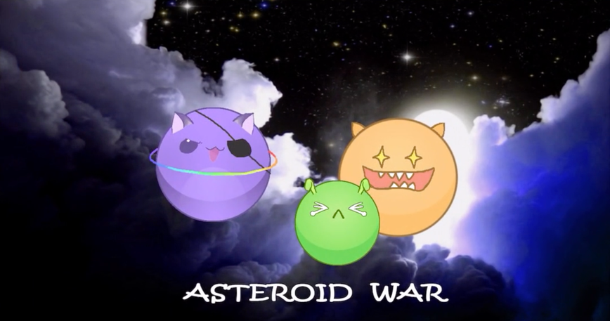

Booting interface

1. Menu interface

The menu is the interface consisting main scene with animated background and several UI components, used by the player to input username, select game mode and difficulty level. But there are shown the game mode options only in out prototype version. In our prototype version, the player can select “timer” or “unlimited” game mode. Once clicking the game mode button, the player will enter the game playing scene.

There is a “History” button like a clock used to skip to game best record pop-out box, which would display the best game records of different game modes.

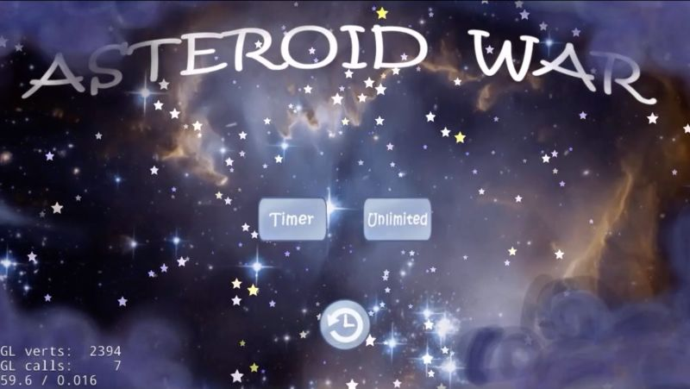

Figure-Game menu interface

1. Game interface

After clicking “Start” button in the Menu interface, the game starts and the hero appears at the center of the screen.

The background is a galaxy universe and the background will change correspondingly as the hero moves. The dynamic rival asteroids (called AI asteroids and demon asteroids) controlled by AI and static tiny particles with a certain weight are allocated here and there in the universe. The hero moving by oriented moving gestures of the player can eat smaller rivals and any tiny particles. And he rivals controlled by artificial intelligence would also do that.

When asteroids eat others, their weights and sizes get larger, but the moving speed would be reduced. That is, the moving speed is inversely proportional to the weight while the size (radius) of the asteroid is proportional to the weight.

Here comes to a special case that hero cannot eat demon asteroids but can only shoot tiny particles to them to decrease their weights. When playing, the player can click the buttons on the bottom right of the interface -- “Shooting” and “Accelerating”. One is used to attack the demon asteroids, and the other is a special and necessary skill for the hero. When the size of hero is very large, there is no denying that the moving speed slows down and it is hard to catch the smaller ones. So hero can adopt such a strategy -- dividing itself into several asteroids to speed up moving and get more chance to eat enemies. Certainly, hero would also take more risks of being eaten by others. So considering which situation the hero should be split or merged adds challenges to this game.

The final score will be calculated according to the number of asteroids the hero ate and defeated when the game is over or time is up, and the highest score will be recorded.

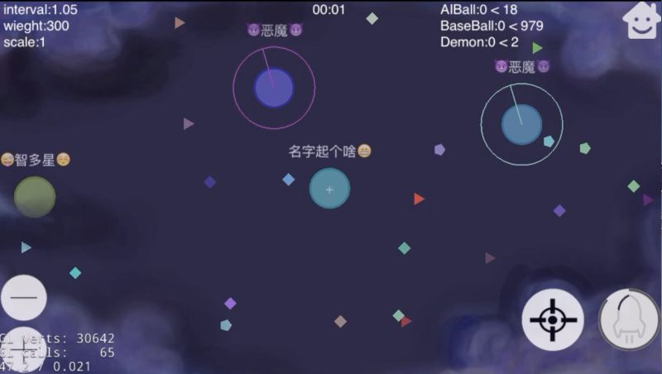

Zoom out

Zoom in

Accelerating

Shooting

Return menu

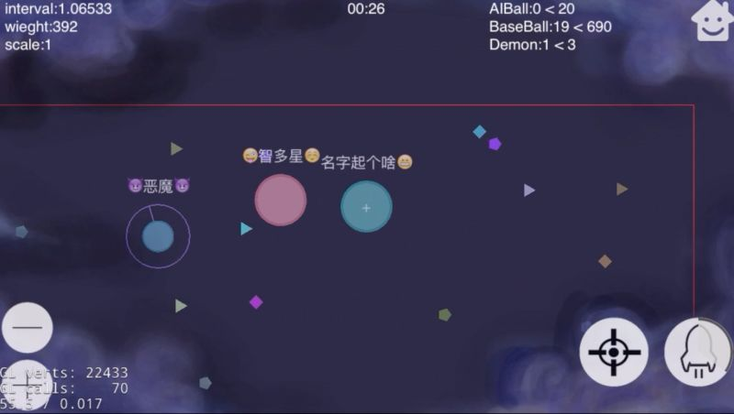

Figure-Game playing interface

1. Game result interface

When the game is over, game result information will pop up consisting of data of weight, time, number of rival asteroids eaten by hero. There are buttons for restarting the game and returning the menu interface.

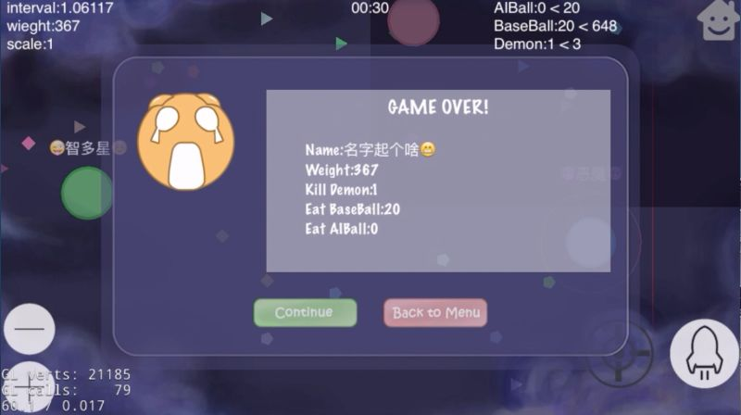

Figure-Game result display

1. History interface

After clicking the “History” bottom below on the menu page there is a pop-out information box showing best game records of different modes and levels and a button to return the menu interface.

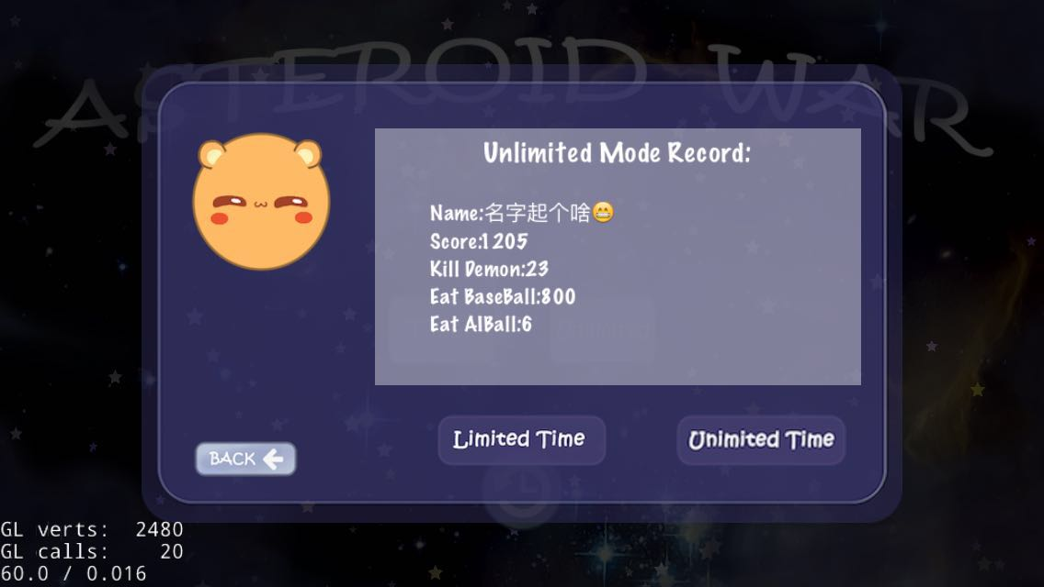 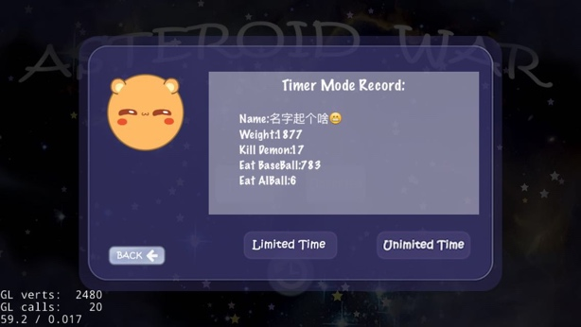

Figure-Game records for Unlimited mode and Timer mode

### Game Mode & Game Levels

On the menu interface, the player selects the game mode and level.

There are two game modes -- unlimited-time mode and timer mode. Levels are set from easiest to hardest for each game mode. Accordingly, the game history will record the best record of each level. In the initial state, only Level 1 is unlocked and only when the last level is passed will the following levels be unlocked. Otherwise the player cannot enter the next level. Each level is set with different prescribed playing time, target weight and AI asteroids settings. As the level of difficulties increases, target weight will be larger (in unlimited mode), the number of demons and AI asteroids will be larger, and the demons will become more sensitive as well.

In our prototype version, only game modes are taken into account. As the time passed by, the demons will be more sensitive to the hero and it will be harder to get higher score.

### The core of Gameplay

The key point of gameplay is that the single player is supposed to annihilate as many smaller asteroids as possible and avoiding being eaten. The moving speed is inversely proportional to the weight while the size (radius) of the asteroid is proportional to the weight. The shooting and speeding up skills are essential for the player to strategically utilize in order to gain a great score in the game.

### Game Difficulties

Different game levels or game difficulties lies on prescribed game time (if it is limited), number of enemies (AI asteroids), sensibility of demon asteroids, aimed weight and initial weight of AI asteroids. All these factors should be taken into consideration to break a new record of the game, flexibly using skills speeding up or shooting to escape the tracing from enemies and annihilate more other asteroids.

# Key Points of Implementation

Aspects:

moves (hero controlled by player and automatically move of AI asteroids)

Skills (shooting, divide and accelerating)

How to merge the smaller ones?

Boundary detection

# Summary

## Characters

Hero: it moves and uses skills by swiping and clicking the buttons, controlled by the player.

Tiny static particles: they spread around the background and can be eaten by dynamic asteroids providing basic energy.

Enemy asteroids controlled by artificial intelligence: AI asteroids and demon asteroids. They move automatically getting close to the nearest asteroids. There is an algorithm to calculate the moving direction and speed with conditions the asteroid weight and the distances of surrounded asteroids. There is difference between AI asteroids and demon asteroids, the player cannot directly eat the demon asteroid but can attack them by meaning of shooting tiny asteroids to them.

## Controls

Controls -- Describe the user interface.

In the menu page, the player can select different game levels and modes. And start a new game by clicking the “Start” button. The game history can be viewed by clicking the “History” button.

In the history page, we can view the game records and the “Back” button is to be clicked to return the menu page.

In the game page, the player can control the hero by swiping the screen indicating the moving direction and tap the skill buttons “shooting” and “accelerating” on the bottom right. The “Home” button is on the top right, which can be clicked to quit the game.

## Graphics

All graphics used in the application is of fantasy and cool style. All background images are with dark hue similar to galaxy and universe. Buttons look like bubbles and all characters are designed in round shape in cute style. The whole design is user-friendly.

There are four characters, the hero, AI asteroids, demon asteroids and tiny static particles. AI asteroids are of normal bubble shapes in different colors with names on the top of asteroid figures. Demon asteroids have different style with common AI asteroids – they are with sparkling halos. The plenty of static particles are in different colors and shapes randomly.

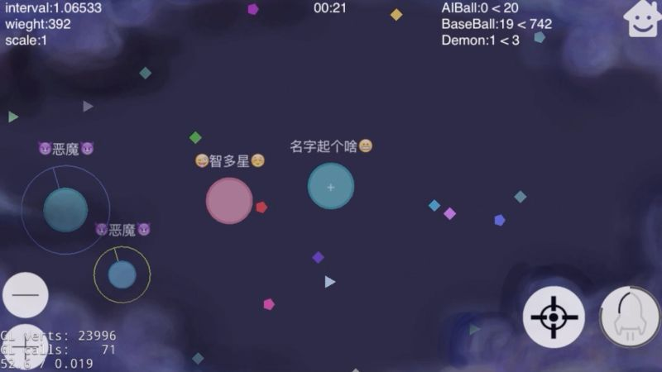

AI Asteroid

Hero Asteroid

Demon Asteroid

Figure-characters of the game

## Sounds and Music

Sounds and background music are selected in delightful and funny manner with a little exciting sense.

Menu and history pages, and main game page apply 2 different pieces of music. Former one is more delightful while later is more competitive and funny. All buttons have the same sound effect. As for the game result pages has two sound effects applied for two results, a new best record or a normal score.

### Improvement and Further Work

1. Game difficulty levels

In each game mode, levels are set from easiest to hardest from Level 1 to Level n. In the initial state, only Level 1 is unlocked and only when the last level is passed will the following level be unlocked. Otherwise the player cannot enter the next level. Each level is set with different prescribed playing time (for time limited mode), target weight and number and initial weights of AI asteroids and Demon asteroid. All these factors should be taken into consideration to win the game, flexibly using skills -- speeding up or shooting to escape attacks from enemies and eat more asteroids.

1. User interface design

There is still room for improvement of graphic interface and audio effect. For example, the hero asteroid can be shown in a unique bitmap or the image of it could be uploaded by the player.

1. Multi-player mode

Current we only achieve the single-player mode, so multi-player mode could add more challenges to this game, in which the players can be partners or competitors, equal to the process of game theory.